* **Create an Android application to demonstrate the different types of menus.**

**a. Context Menu b. Option Menu**

**1) Context Menu**

**Code:-**

packagecom.example.contextmenu  
  
import androidx.appcompat.app.AppCompatActivity  
import android.os.Bundle  
import android.view.ContextMenu  
import android.view.MenuItem  
import android.view.View  
import android.widget.TextView  
import android.widget.Toast  
  
class MainActivity: AppCompatActivity() {  
override fun onCreate(savedInstanceState: Bundle?) {  
super.onCreate(savedInstanceState)  
setContentView(R.layout.*activity_main*)  
  
vartext1:TextView = findViewById(R.id.*textview1*)  
text1.setOnCreateContextMenuListener(this)  
 }  
  
override fun onCreateContextMenu(menu: ContextMenu?, v: View?, menuInfo: ContextMenu.ContextMenuInfo?) {  
super.onCreateContextMenu(menu, v, menuInfo)  
createMyContextMenu(menu)  
 }  
  
fun createMyContextMenu(menu: ContextMenu?) {  
varmenu1: MenuItem? = menu?.add(0,0,0,"First Item")  
varmenu2: MenuItem? = menu?.add(0,1,1,"Second Item")  
varmenu3: MenuItem? = menu?.add(0,2,2,"Third Item")  
varmenu4: MenuItem? = menu?.add(0,3,3,"Fourth Item")  
 }  
  
override fun onContextItemSelected(item: MenuItem): Boolean {  
return handlemyContextMenu(item)  
 }  
  
fun handlemyContextMenu(item: MenuItem): Boolean {  
varid:Int= item.*itemId*when(id){  
0 ->Toast.makeText(*applicationContext*,"You clicked Item 1",Toast.*LENGTH_LONG*).show()  
1 ->Toast.makeText(*applicationContext*,"You clicked Item 2",Toast.*LENGTH_LONG*).show()  
2 ->Toast.makeText(*applicationContext*,"You clicked Item 3",Toast.*LENGTH_LONG*).show()  
3 ->Toast.makeText(*applicationContext*,"You clicked Item 4",Toast.*LENGTH_LONG*).show()  
 }  
return false  
}  
}

**OUTPUT:**

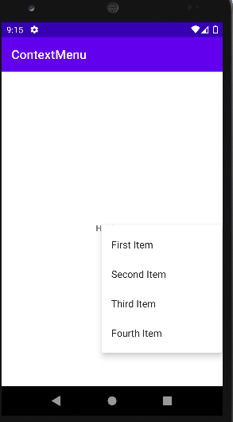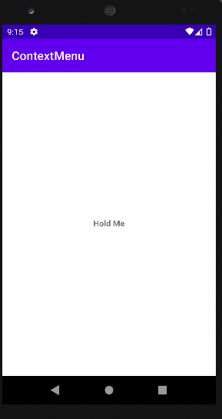

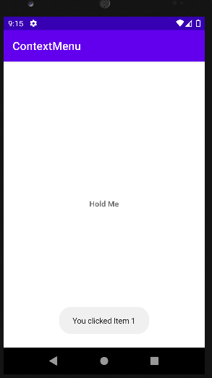

**2) Menu List**

**Code:-**

packagecom.example.menulist  
  
import androidx.appcompat.app.AppCompatActivity  
import android.os.Bundle  
import android.view.Menu  
import android.view.MenuItem  
import android.widget.Toast  
  
class MainActivity: AppCompatActivity() {  
override fun onCreate(savedInstanceState: Bundle?) {  
super.onCreate(savedInstanceState)  
setContentView(R.layout.*activity_main*)  
 }  
  
override fun onCreateOptionsMenu(menu: Menu?): Boolean {  
super.onCreateOptionsMenu(menu)  
createmyMenu(menu)  
return true  
}  
  
fun createmyMenu(menu: Menu?) {  
varmenu1:MenuItem? = menu?.add(0,0,0,"Item 1")  
varmenu2:MenuItem? = menu?.add(0,1,1,"Item 2")  
varmenu3:MenuItem? = menu?.add(0,2,2,"Item 3")  
varmenu4:MenuItem? = menu?.add(0,3,3,"Exit")  
  
 }  
  
override fun onOptionsItemSelected(item: MenuItem): Boolean {  
return hadnlemyMenuItemEvent(item)  
 }  
  
fun hadnlemyMenuItemEvent(item: MenuItem): Boolean {  
varid:Int= item.*itemId*when(id){  
0 ->Toast.makeText(*applicationContext*,"You clicked Item 1",Toast.*LENGTH_LONG*).show()  
1 ->Toast.makeText(*applicationContext*,"You clicked Item 2",Toast.*LENGTH_LONG*).show()  
2 ->Toast.makeText(*applicationContext*,"You clicked Item 3",Toast.*LENGTH_LONG*).show()  
3 ->finish()  
 }  
return false  
}  
}

**Output:**

